Design Flow and Graphs

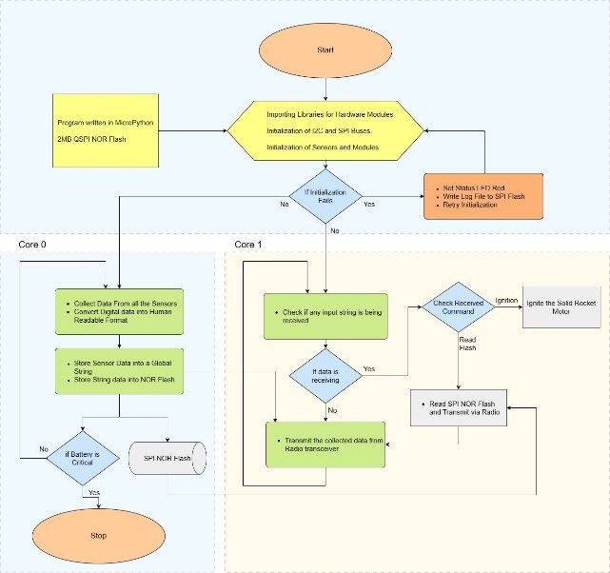

Fig-Design Flow of Electronic System Program

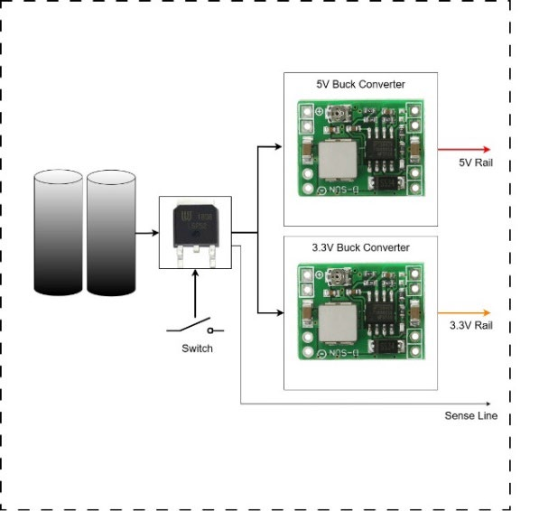

Fig-Block Diagram of Electrical Power Subsystem

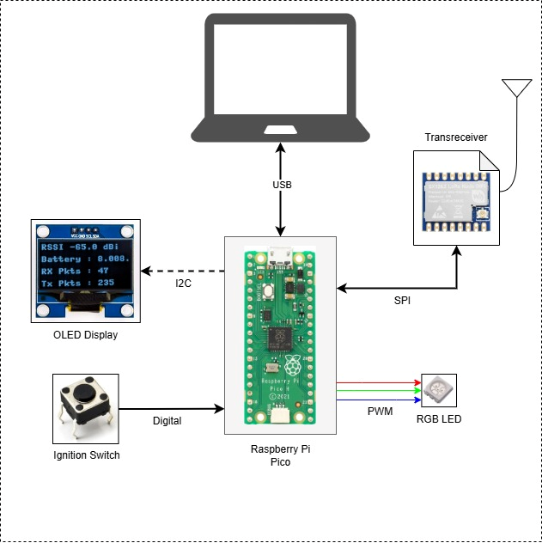
Fig-Ground Control Station Block Diagram

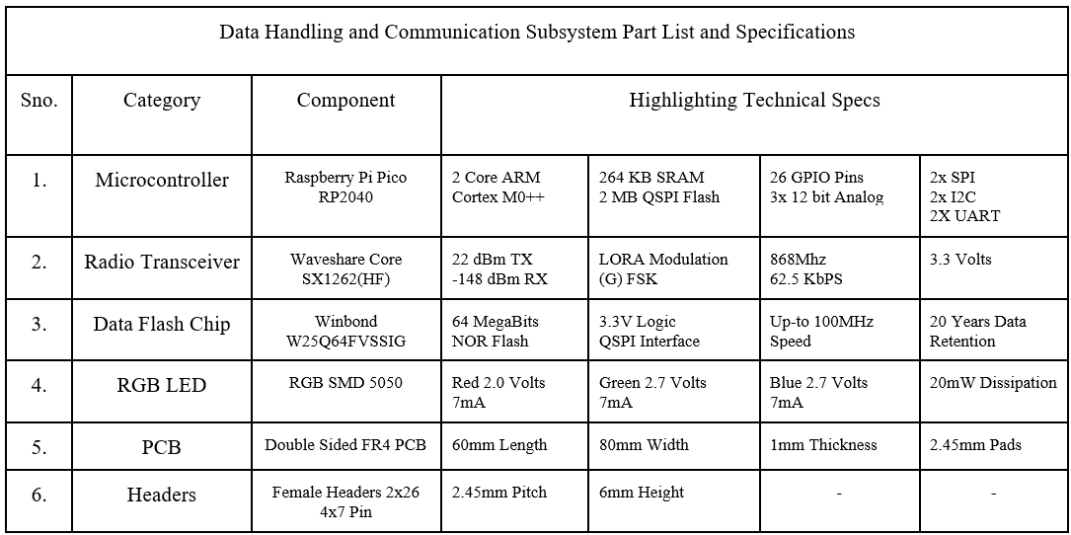

Fig-Data Handling and Communication Subsystem Part List and Specification

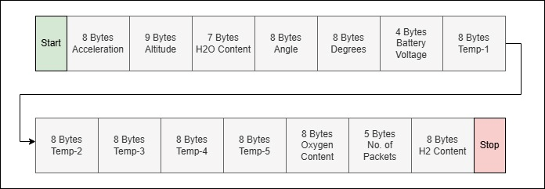
Fig-Data Packet Composition

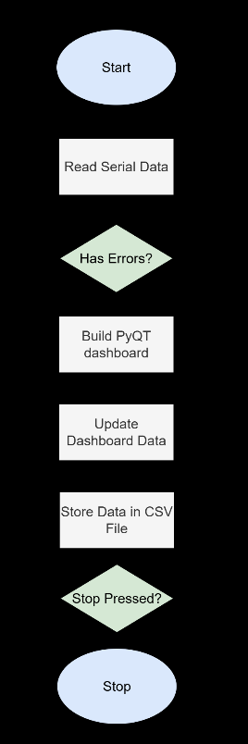

Fig-GCS Program Workflow

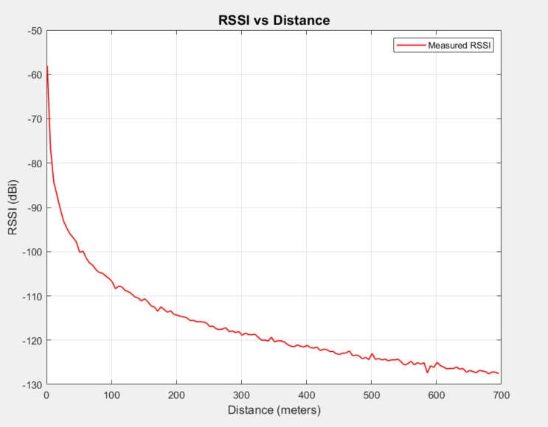

Fig-Signal Strength vs Distance

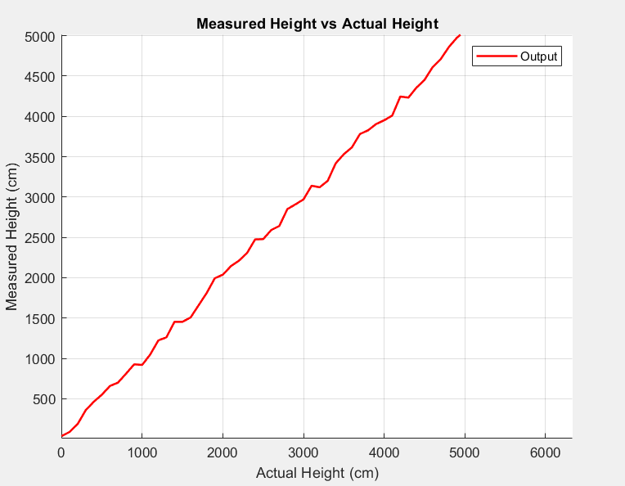

Fig-Altitude Measured vs Actual

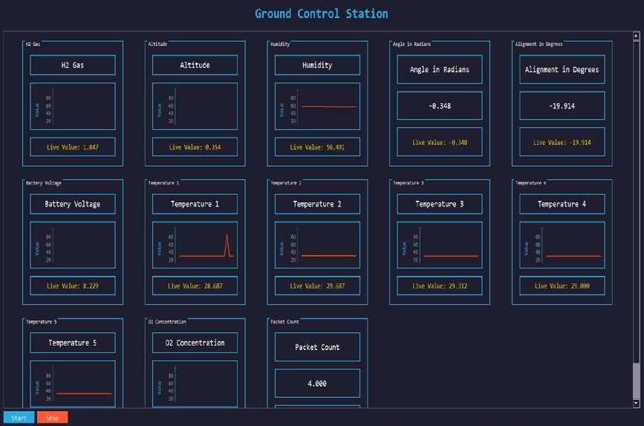

Fig-Dashboard

